This document is binding proof of a Privacy & Confidentiality Agreement for the purposes of gathering health and personal information for academic and professional understanding.

Privacy & Confidentiality Agreement is required to serve as a contract to ensure your personal health information will not be shared with anyone except the staff within Suture Self Holistic Inc for the sole purpose of being aware of your current medical condition, current medication regimen, and for academic and professional understanding only.

By signing below, I promise to keep all your information private and confidential for education purposes only.

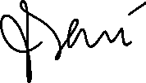

By signing below, you understand that I’m committed to holding your personal health information for the benefit of your health and wellness only.

